Student database

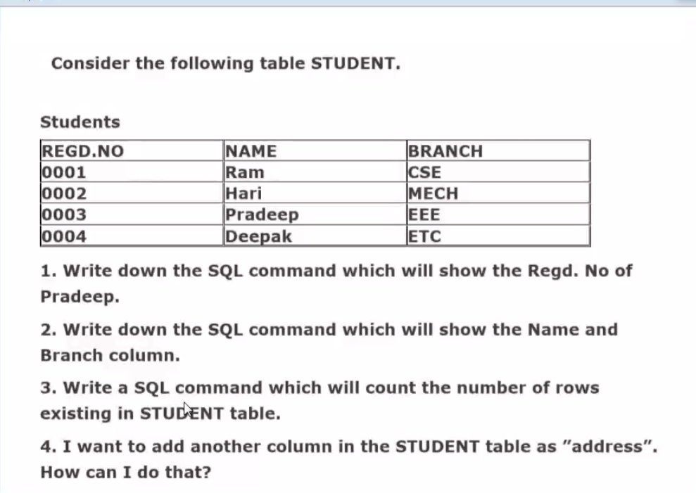

Creating the database and inserting the values into them.

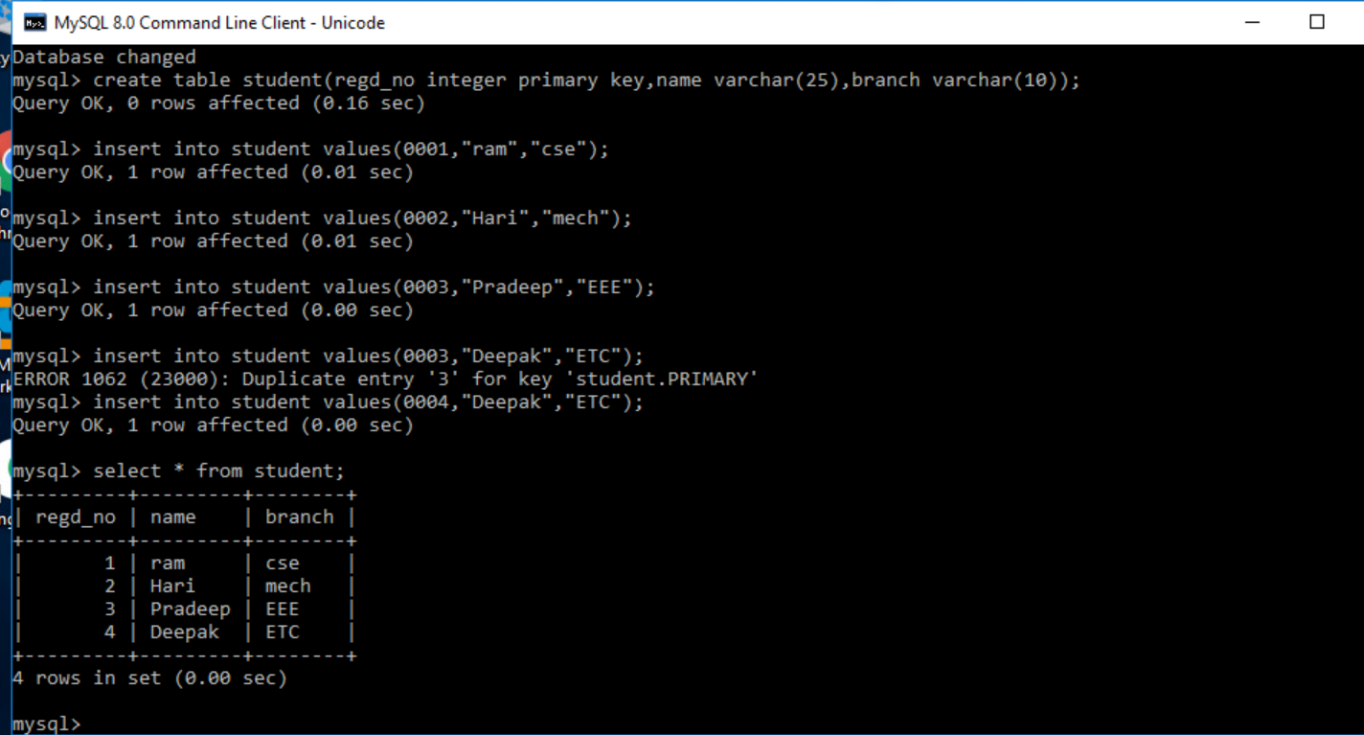

1.



2.

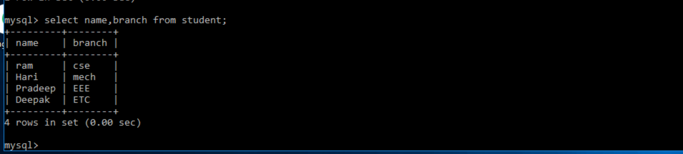

3.



4.

